Notes for setting up the demo from http://static.springframework.org/osgi/demos/integration-test-demo/part-1/int-testing-part1.html

The maven command that worked to create the project:
mvn archetype:create -DgroupId=demo -DartifactId=demo -DarchetypeArtifactId=maven-archetype-archetype

Here is the pom.xml from the demo:
<project xmlns="http://maven.apache.org/POM/4.0.0" xmlns:xsi="http://www.w3.org/2001/XMLSchema-instance"

xsi:schemaLocation="http://maven.apache.org/POM/4.0.0 http://maven.apache.org/maven-v4_0_0.xsd">

<modelVersion>4.0.0</modelVersion>

<groupId>demo</groupId>

<artifactId>demo</artifactId>

<version>1.0-SNAPSHOT</version>

<name>Archetype - demo</name>

<url>http://maven.apache.org</url>

<dependencies>

<dependency>

<groupId>org.springframework.osgi</groupId>

<artifactId>spring-osgi-test</artifactId>

<version>1.0</version>

<scope>test</scope>

</dependency>

<dependency>

<groupId>org.springframework.osgi</groupId>

<artifactId>spring-osgi-annotation</artifactId>

<version>1.0</version>

</dependency>

<dependency>

<groupId>org.slf4j</groupId>

<artifactId>jcl104-over-slf4j</artifactId>

<version>1.4.3</version>

</dependency>

<dependency>

<groupId>org.slf4j</groupId>

<artifactId>slf4j-api</artifactId>

<version>1.4.3</version>

</dependency>

<dependency>

<groupId>org.slf4j</groupId>

<artifactId>slf4j-log4j12</artifactId>

<version>1.4.3</version>

<exclusions>

<exclusion>

<groupId>log4j</groupId>

<artifactId>log4j</artifactId>

</exclusion>

</exclusions>

</dependency>

<dependency>

<groupId>org.springframework.osgi</groupId>

<artifactId>log4j.osgi</artifactId>

<version>1.2.15-SNAPSHOT</version>

</dependency>

<dependency>

<groupId>org.springframework.osgi</groupId>

<artifactId>junit.osgi</artifactId>

<version>3.8.2-SNAPSHOT</version>

<scope>test</scope>

</dependency>

<dependency>

<groupId>org.eclipse.osgi</groupId>

<artifactId>org.eclipse.osgi</artifactId>

<version>3.2.2</version>

<type>jar</type>

<scope>provided</scope>

</dependency>

</dependencies>

<repositories>

<repository>

<id>spring-ext</id>

<name>Spring External Dependencies Repository</name>

<url>http://springframework.svn.sourceforge.net/svnroot/springframework/repos/repo-ext/</url>

</repository>

<repository>

<id>spring-osgi-artifacts</id>

<name>Spring Portfolio OSGi Artifacts Repository</name>

<snapshots>

<enabled>true</enabled>

</snapshots>

<url>http://s3.amazonaws.com/maven.springframework.org/osgi</url>

</repository>

</repositories>

</project>

In Eclipse, the M2_REPO was not defined, so go to Preferences->Java->Build path and defined the variable to point to the maven2 repository (see screenshot):

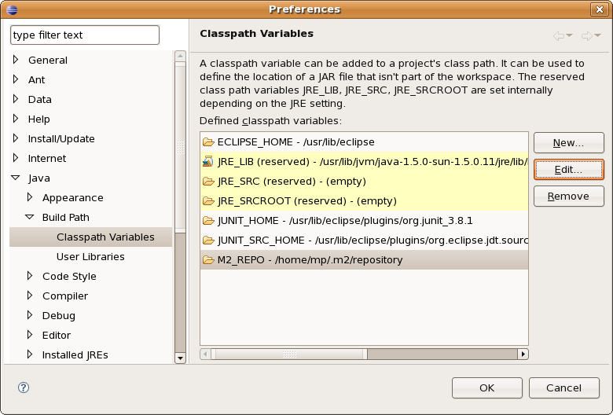

Another thing to assert is that the classes folder is configured to “test-classes”. Otherwise it will complain on the test execution that the test-classes folder is not present.
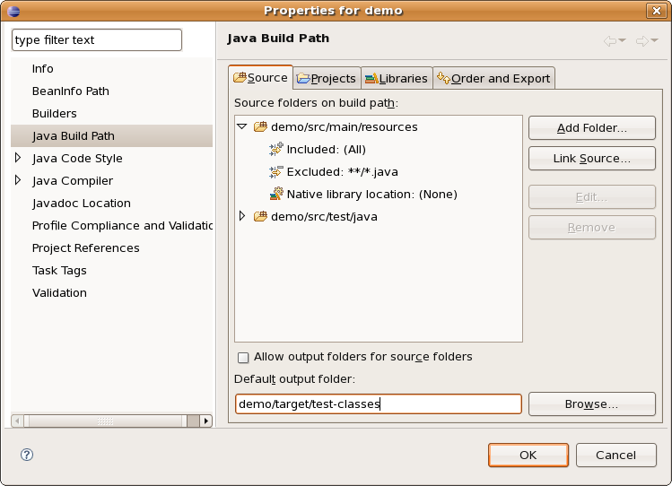

The log4.properties file:
log4j.rootcategory=info, stdout

log4j.appender.stdout=org.apache.log4j.ConsoleAppender
log4j.appender.stdout.layout.ConversionPattern=%t %p [%c] - %m%n
log4j.appender.stdout.layout=org.apache.log4j.PatternLayout
log4j.appender.stdout.threshold=TRACE

log4j.logger.org.springframework=INFO
log4j.logger.org.springframework.osgi.test=INFO

I had the problem that the log4j.properties file was not found. To resolve, it's directory has to be added to the classpath. I put the log4j.properties file in the main folder (demo). Select Run... and define the additional classpath element (under Advanced->Add folder):
